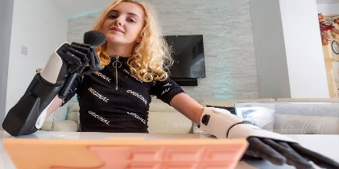
REAL-LIFE CYBORGS
▪ Watch the powerpoint presentation then complete the grid
Real  Life  Cyborgs | Who is he / she | Device(s) +  part(s) of the body | Functions of the device | Reasons for having that device | Particular characteristics
Zac Vawter

Rob Spence

Tilly
Lockey

Neil Harbisson

